Projet: Régions de la France
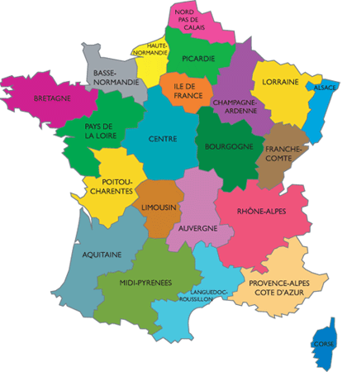
Your name:_________________________________
Your partners name:________________________

Your region:__________________________________
Due date:___________________________________
Description: You and a partner will research a region of France. You will create a large brochure (I will show you and example) that explores the geography, cities, food and culture of that region.
*NOTE: As you are doing your research BOTH you and your partner should complete this guide.
Checklist :
___ What are the main cities in the region (must include the capital)? List 1-3 cities and their populations.
Cities- __________________ ___________________ ______________________
Pop.- __________________ ___________________ ______________________

___What cities in N.C are roughly the same size?
Cities ________________ ___________________ ______________________
Pop.- ________________ ___________________ ______________________

___Are there famous bridges, monuments, or churches in these cities? Of what (or for whom) and why?
__________________________________________________________________________________________________________________
__________________________________________________________________________________________________________________
__________________________________________________________________________________________________________________
__________________________________________________________________________________________________________________

___What is the geography like? Describe it in your own words using at least 3 good adjectives.
___________________________________________________________________________________________________________________

___Are there main geographical attractions? Mountains? Ocean? Sea? Hills? Rivers? Vineyards? Farms? Where are these places w/ in the region or what cities are they near? Label clearly w/ caption and description on a map of your region.
_____________________________________________________________________________________________________________________
_____________________________________________________________________________________________________________________
_____________________________________________________________________________________________________________________

____What do the people do at the geographical attractions and why is it an attraction (ex. tall peak, famous battle?,
unique beach)
______________________________________________________________________________________________________________________________________________________________________________________________________________________________________________________
___________________________________________________________________________________________________________________________

____Does this region share cultural similarities with another nearby country? Give examples (architecture, food, language).
___________________________________________________________________________________________________________________________
___________________________________________________________________________________________________________________________

___What is that region known for producing? Wine (which kinds of grapes)? Meat (What kinds of cows/sheep, famous? Cheese? Textiles? Fragrances? Make-up? Is there a famous school at this place? What do the French know this region for? What does the production process look like?
_________________________________________________________________________________________________________________________
_________________________________________________________________________________________________________________________
_________________________________________________________________________________________________________________________
_________________________________________________________________________________________________________________________
_________________________________________________________________________________________________________________________
_________________________________________________________________________________________________________________________

____Do the principal products made here have anything to do w/ the geography or climate? Explain.
___________________________________________________________________________________________________________________________
__________________________________________________________________________________________________________________________

_____What popular or famous food dishes are unique to this region? Print 3 different recipes (in French) and include photos.
You must include at least 2 on your brochure.
___________________________ ___________________________ _______________________________

____Why are these foods eaten here? Is there a history to the famous food dish?
_______________________________________________________________________________________________________________________

____Are there well-known events that take place here? What happens during these? When and why? (Religious observances, festivals etc.)
___________________________________________________________________________________________________________________________
___________________________________________________________________________________________________________________________
___________________________________________________________________________________________________________________________
____Do the people in this region have an accent? Youtube search: accent (your region) and see how it sounds.
__________________________________________________________________________________________________________________________

____What would you want to visit do in this region and why?
___________________________________________________________________________________________________________________________
___________________________________________________________________________________________________________________________

For the brochure:
____A map of france w/ highlighted region.
____A map of region w/ important cities and geographical attractions clearly labeled.
____Individual sections for those cities explaining famous monuments, rivers, churches etc.
___Clear size comparison city from N.C.
____A section for products in this region and descriptions.
____A section for famous dishes in this region w/ description and at least one posted recipe in French.
____4 more pictures related to the presented content.

Final Checklist:
____The prodcut is: ____ well organized ____ easy to read ___visually attractive
____I am proud of my w ork. ;)

